# Day-70

# Randomization

## **Code**

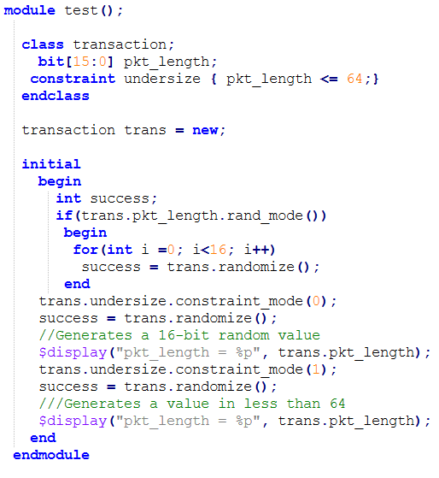

## **Simulation results**

